**MAXIMIZING OPPORTUNITIES FOR STUDENTS**

**WITH A DISABILITY**

**PROGRAM MODIFICATIONS**

|  |
| --- |
| ***TIP:***  ***When you modify activities, only do so:***   * ***When necessary;*** * ***To the extent necessary; and*** * ***Without jeopardizing the integrity of the activity.*** |

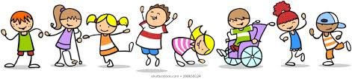

**RANGE OF MODIFICATIONS**

As with participation levels, a range of modifications can be applied to physical education opportunities for students with a disability, depending on the student and the situation.

**Minimal modifications have little effect on the other participants or the integrity of the activity.** For example, students wear brightly coloured pinnies to help a student with a visual impairment identify team members; a student with cerebral palsy serves the volleyball from an identified mark inside the court; a student in a wheelchair uses a gymnastics ribbon during the creative dance unit to express rhythm and flow; a start flag is used to signal to a runner who is deaf that the race is beginning.

**Moderate modifications may affect the role the student assumes within the activity.** For example, a student who uses crutches is designated to take the throw-ins during soccer games; a student in a wheelchair covers a specified area for basketball; a tandem cycle is provided for a student with a visual impairment.

**Considerable modifications often affect the integrity of the activity and are generally not recommended.** If the goals of the program are not being met for the student, consider an alternate activity.

**MODIFICATIONS**

|  |
| --- |
| ***TIP:***  ***Modifications can be made to the:***   * ***Equipment*** * ***Skill complexity*** * ***Rules of the game; and/or*** * ***Distance/space.*** |

|  |  |
| --- | --- |
| **EQUIPMENT MODIFICATION** | |
| Lighter, softer, larger ball | Slows game and allows more time to prepare for and execute skill |
| Shorter, lighter, striking implement | Allows greater control for weaker and less skilled player |
| Larger striking implement, larger goal or target area | Reduces number of misses and increases opportunity for success |
| Lighter, softer, smaller balls | More easily caught and retained |
| Bean bags substituted for balls | Not as elusive as balls and may be easier to throw for a student with poor hand function |
| Partially deflated balls for dribbling and kicking activities | Slows movement of the ball and allows more time to prepare and execute the skill |

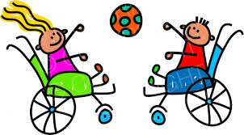

|  |  |
| --- | --- |
| **SKILL LEVEL MODIFICATION** | |
| Skills such as wheeling substituted for running, rolling a ball off a lap for kicking, striking a soccer ball with a floor hockey stick instead of the foot | Increases success and opportunity to be involved in game play |
| Tasks simplified for example, drop and catch the ball rather than bounce it consecutively | Increases success and opportunity to be involved in class activity |
| Props used to enhance skills; for example, a towel extends the reach for tag games | Increase level of success and motivation for participation |

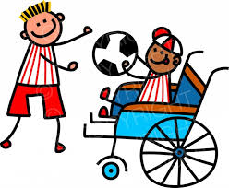

|  |  |
| --- | --- |
| **RULE MODIFICATION** | |
| No direct challenge when ball comes within 2 metres of player | More time to prepare for and execute skill |
| Differential scoring system allowing points for specific behaviours, for example, passing, touching ball | Recognizes effort, learning and success |
| Only essential rules used | Reduces game complexity |
| Complete end line used as goal | Allows more frequent scoring opportunities and use of multiple goalkeepers |
| Unlimited number of contacts with ball before crossing net or centre line | Increases opportunity to make contact with ball |
| Unequal numbers in team groupings | Matches teams |
| Number of trials increased; for example, unlimited number of attempts to strike ball | Increases level of success and opportunity to practice emerging skills |

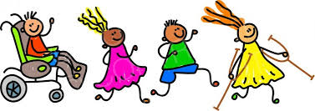

|  |  |
| --- | --- |
| **DISTANCE/SPACE MODIFICATION** | |
| Smaller playing area used | Increases opportunity for application of skill and participation in the flow of the game |
| Target lowered or moved closer | Reduces number of misses and increases opportunity for success |
| Start or finish line moved; for example, next runner in relay starts when student reaches halfway point | Increases level of success and opportunity to be involved in game play |
| Designed position/function assigned to reduce area to be travelled; for example, designated pitcher, goalie or foul shooter | Increases successful participation in the game |