Creating an IEP in MyEd BC

- Select Student Services School View:

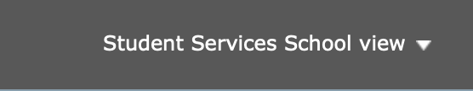

- Click on Student top tab:

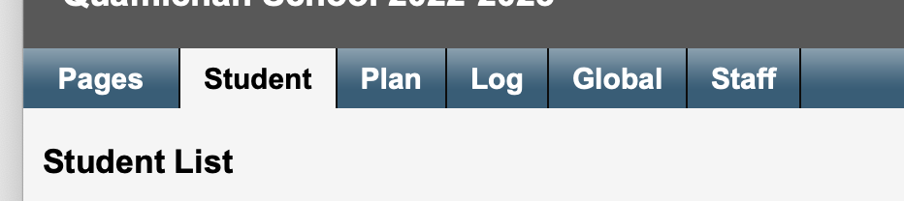

- Change the filter to All records:

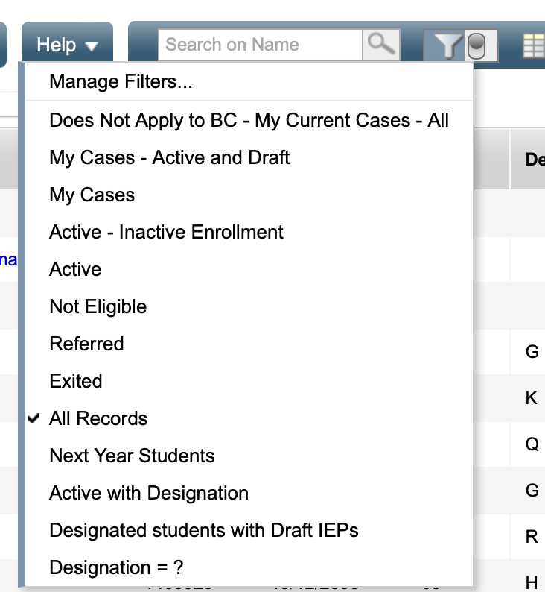

Now you will assign yourself as the case manager, and then you will be able to use the “My cases” filter when you select this student list.

Follow this path:
Options -> enroll -> click on the magnifier and select the student (s) from the pick list -> select yourself as the case manager -> Use September 1, 2022 as the start date and June 30, 2023 as the end date -> name the plan “79-CBIEP-22/23”

You do not need to name the student in the plan as each plan will be created in the students’ accounts.

You can select your whole caseload and only do this once, or you can do it one at a time if you feel more comfortable.

You will then get a pop up that tells you that student plans have been created.

To start writing the plans:

In the student top tab, select the student (from the “My Cases” filter) and then click on the Plans side tab:

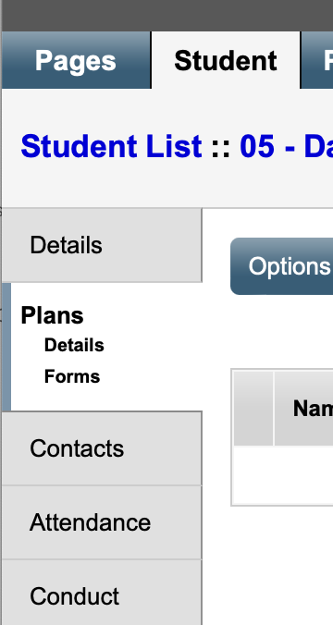

The Dictionary icon will appear on the ribbon:

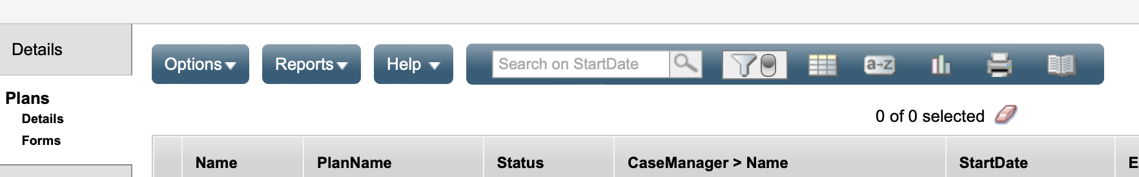

Click on the dictionary and select All:

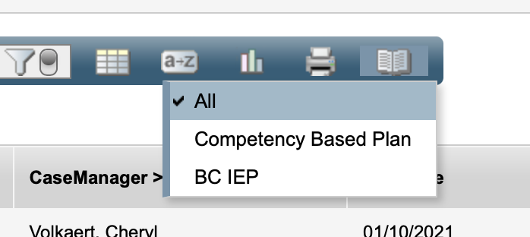

This will open any plans created for the selected student on the list.
Click on the name of the plan highlighted in blue – you may now start to populate the plan with your new details.

If a student you selected to “enroll” does not appear on the list:

This means that a plan has already been created for them likely in another district or by another school. If the plan is NOT a competency-based IEP, it will not copy over to the new plan. You will need to create a new plan for that student:

Follow this path:

Student top tab -> Plans side tab -> click on “renew plan” (not renew plan case manager) -> select the student -> do NOT select a plan, leave it blank to create a new plan -> date the new plan September 1 start and June 30, 2023 end -> name the plan 79-CBIEP-22/23 (do not include student name) -> ok

This will create a new plan that you can then start to populate for the student.

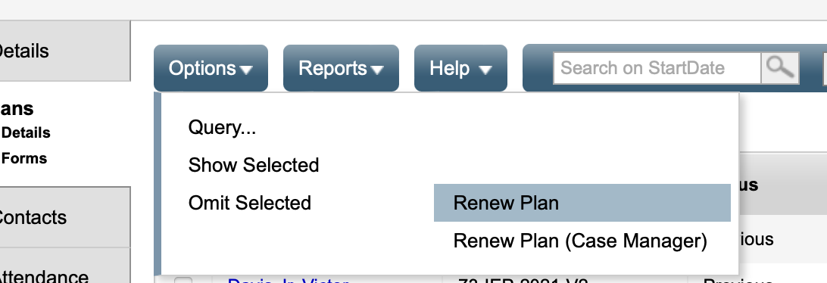

This will bring up the renew plan window:

